Financial Engineering – 630

Portfolio Theory and Applications

Completed By: Riley Heiman, Bryce Streeper

Advisor: Professor Papa Momar Ndiaye

Date: 12/13/2022

Final Note: There are multiple files in this folder

* **FE-630** **Project** is the final presentation.
* **Python** is a folder representing the Jupiter notebooks, which can reproduce our results from start to finish.
  + The python notebook *FE_630_Final_Project* represents the data collection, optimization, and rolling window.
  + The python notebook *EDA* stands for Exploratory Data Analysis. The purpose of this notebook is to generate histograms and time series for our final presentation.

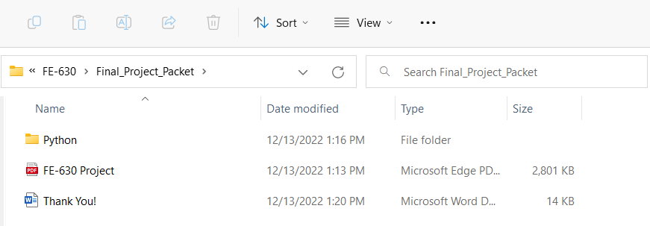

Thank you

The final project was a direct application of portfolio theory. Although it was challenging, it provided hands-on experience programming in Python, and analyzing market data. We appreciate the support provided throughout the semester.

Sincerely,

-Bryce & Riley